**Learn Spanish with Ken-Ton Community Ed!**

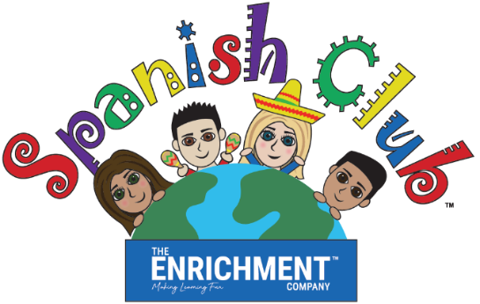

**Capture the opportunity in your child’s development!**

SPANISH FOR THE ELEMENTARY YEARS is an educationally oriented fun and interactive program designed specifically for the K–5 elementary student. The unique six-week curriculum features foundation vocabulary introduced through games, singing and hands-on activities. Students are able to compound words and begin forming simple sentences. Different sessions are offered during the school year using a 5-year rotation of lesson plans. **New vocabulary and activities are introduced with each 6-week session!** Returning students can continue expanding their vocabulary base and new students can begin building their vocabulary base. **New and returning students can join.** Research studies have indicated the benefits of introducing foreign language skills at an early age! Join the fun!

**Enroll your child for this amazing educational experience!**

**There are two exciting options – in-person classes or virtual classes:**

**IN-PERSON CLASSES** will be held at the former KENMORE MIDDLE SCHOOL (across from the Kenmore library on Delaware Rd) on WEDNESDAYS from 5:45p.m. – 6:30p.m. in room 206. Classes meet 2/10, 2/24, 3/3, 3/10, 3/17, 3/24 (no class 2/17). The class fee is $89 for the 6-week session. **Covid protocol will be followed and there are a very limited number of spaces available in the class!**

**OR**

**VIRTUAL CLASSES** will be held in a fun, live format on TUESDAYS from 6:00p.m. – 6:40p.m. Classes are interactive and meet on 2/9, 2/23, 3/2, 3/9, 3/16, 3/23 (no class 2/16). Class link will be emailed prior to the first class. The class fee is $89 for the 6-week session. Class size is limited!

Registrations are through KenTon Community Education and can be made online, by mail or in person. Visit the KenTon Community Education website for all the registration details at <https://register.ktufsd.org/wconnect/ace/home.htm>. If you have any questions, contact Ken Ton Community Ed at 874-8500 ext 32621 or contact The Enrichment Company at 1-833-436-7424. For class details, visit [www.TheEnrichmentCompany.com](http://www.TheEnrichmentCompany.com).

**REGISTRATION DEADLINE: FRIDAY, JANUARY 29th**

KENTON -Winter 2021