KENMORE-TOWN OF TONAWANDA UNION FREE SCHOOL DISTRICT


2017-2018

STUDENT TEACHER
HANDBOOK
INTRODUCTORY

STUDENT TEACHERS

The Kenmore-Town of Tonawanda Union Free School District shall cooperate with teacher training institutions in the placement of student teachers in order to provide beginning teachers with the best possible student teaching experience. Student teachers shall be protected from liability for negligence or other acts resulting in accidental injury to any person by the School District, as provided by law.

Staff that collaborate with student teachers are expected to provide a quality learning environment wherein the student teacher is afforded varied opportunities to enhance learning for both the student teacher and the district students. The driving factor in the administrator’s identification of collaborating teachers shall be the teacher’s commitment to improvement of the teaching and learning process for all people.

Student teachers shall at all times be subject to the policies, practices, and procedures of the District. Student teachers serving in the schools of this District shall be responsible to the principal for their conduct and to the cooperating teacher for their performance.

A student teacher shall be removed by the Superintendent or his designee if it is determined that his/her presence is detrimental to the welfare of the students, welfare of the school system, or if it is found that he/she is academically unprepared for student teaching.

Your dress and grooming should be appropriate to your position. As a District student teacher, you often provide the public the first, and sometimes the only impression of the School District. You may greet the public by telephone or in person. Information must be accurate and should always be exchanged in a courteous manner. Complaints or criticisms should be handled with tact. If you are uncertain how to handle a situation, please talk with your principal or cooperating teacher. It is also expected you show the same courteousness and respect to all District employees.

CONFIDENTIAL INFORMATION

In the course of performing your duties, you may have access to information about school business, students, tests, other employees, and records that should be considered confidential. If you are uncertain, do not release information prior to consulting your principal or cooperating teacher.

DISTRICT EXPECTATIONS OF STUDENT TEACHERS

- Professionalism

It is the responsibility of the student teacher to strive for a quality placement. Student teachers should become familiar with building procedures as well as the classroom atmosphere. All questions and concerns should be directed to the cooperating teacher. Student teachers are encouraged to discuss specific unit/lesson plans with the cooperating teacher before implementation, while adhering to the high standards of conduct and professionalism expected of all District employees and visitors.

- Preparation

Student teachers should wear their identification badge at all times. Upon arrival, student teachers should report to the main office to sign-in. Be sure to get phone numbers and email addresses so that you can notify appropriate personnel if you will be late or absent. Please check with the cooperating teacher regarding the building’s process for daily attendance and/or sign-in. It is essential to practice time management and organizational skills to be an effective teacher. Be sure to arrive early enough to become oriented to the daily activities and prepare to stay beyond the school day as necessary.

- Teaching Effectiveness

It is the responsibility of the student teacher to observe and implement the instructional process in a manner that incorporates individual teaching style and personality. Student teachers will be expected to create/provide detailed lesson plans, understand and deliver the curriculum, maintain classroom control, grade papers, attend meetings and/or field trips with the cooperating teacher and any other daily responsibilities of the cooperating teacher. Student teachers should be prepared to complete bulletin boards, use technology, and create materials for students. Student teachers may also need to take students to specials and lunch, and assist with dismissal and bus duty responsibilities. The goal is to provide all student teachers with the opportunity to experience many aspects of the teaching profession. If the cooperating teacher believes the student teacher is not meeting the district’s criteria, he will contact the building administration to discuss possible solutions.

- Professional Performance Goals

It is the District’s expectation that student teachers strive to reach the following professional performance goals:
- To insure NYS standards are understood, accepted and demonstrated
- To provide support for the implementation of NYS standards
- To provide accountability for decisions to recognize teacher improvement
- To enhance professional growth
- To provide feedback on professional issues
- To focus on classroom technique improvements
- To develop and implement a professional growth plan

The framework for Professional Performance encompasses the following key areas:
Planning & Preparation  Understanding content, designing instruction and assessment  - demonstrating knowledge of content  - demonstrating knowledge of students  - selecting instructional goals  - demonstration knowledge of sources  - designing coherent instruction  - assessing student learning | Instruction  Teacher’s skill in engaging students  - communicate clearly and accurately  - using questions and discussion techniques  - engaging students in learning  - providing feedback to students  - demonstrating flexibility and responsiveness
Classroom Environment  Establishing an environment conducive to learning  - creating an environment of support  - establishing a culture for learning  - managing classroom procedures  - managing student behavior  - organizing the physical space | Professional Responsibilities  Additional professional responsibilities  - reflecting on teaching  - maintaining records  - communicating with families  - contributing to school and district  - growing professionally  - showing professionalism

From: Danielson, C. (1996) Enhancing professional practice: A framework for teaching.
Alexandra, VA: Association for Supervision and Curriculum Development

- Safety and Welfare

Student teachers are also responsible for the safety and welfare of the students in their classes. Immediately become familiar with fire drill directions and emergency exits. The cooperating teacher may leave the student teacher alone with the students; the student teacher is in charge and accountable for them. Do not leave any class unsupervised for any reason. If a student teacher is in need of immediate assistance, he/she should call the main office.

- Building Protocol

Check with the cooperating teacher or lead secretary regarding parking. If a student teacher will be late or absent, please call the school office and leave a message.
WHAT YOU CAN EXPECT FROM THE COOPERATING TEACHER

The cooperating teacher:

- is the direct contact person for a student teacher
- is the liaison between the District and the college/university.
- is a role model for all students.
- is the instructional guide.
- is a resource for ideas/advice.
- is the expert.
- offers guidance and support.
- facilitates educational goals.
- encourages the student teacher to observe other classes.
- encourages practical implementation.
- provides a safe environment for application.
- will establish a positive rapport with the student teacher.
- will model teaching and classroom management strategies.
- will encourage appropriate and professional practices (dress/attendance/organization).
- will answer questions of the student teacher.
- will conference regularly with the student teacher.
- will assist in preparing units/lessons/projects.
- will gradually increase the responsibilities of the student teacher.
- will offer immediate feedback and constructive criticism.
- will report issues and/or concerns to the college/university and the building administration, if necessary.

WHAT YOU CAN EXPECT FROM THE BUILDING ADMINISTRATOR

The administrator is responsible for approving the application of cooperating teachers and the approval of student teachers within his/her building. The student teacher may request the building principal to come in and observe for the purpose of professional feedback and/or constructive criticism.

B. DISTRICT ORGANIZATION AND OPERATION SECTION

Board of Education Members

2017-2018

Name Title Term Expires

Dr. Jill O’Malley President 2020
jomalley@ktufsd.org

Mr. Andrew Gianni Vice President 2018
agianni@ktufsd.org

Mrs. Christine Cavarello Trustee 2019
ccavarello@ktufsd.org

Ms. Michelle Tarbox Trustee 2020
mtarbox@ktufsd.org

Dr. Thomas Reigstad Trustee 2019
treigstad@ktufd.org

KENMORE TONAWANDA UFSD
BOARD OF EDUCATION
District Clerk
G. SantaMaria

Superintendent
Stephen Bovino
Community Relations Coordinator
P. Fanelli
Secretary to the Superintendent
G. SantaMaria

Assistant Superintendent Finance
J. Brucato

Assistant Superintendent Human Resources
C. Swiatek
Assistant Superintendent Student Services & Instruction
R. Zymroz

Elementary
Principals

(5)

Director of Special Education

M. Lewis
Directors of Elementary & Secondary Education
H. Lyon
T. Gerchman

High School Principals

(2)

Middle School Principals

(2)

Supervisor of Physical Education Recreation & Athletics
B. Banker

Sup of Elementary Special Education

B. Chmura
Sup of Secondary Special Education

F. Spagnolo

QUICK REFERENCE

Superintendent of Schools…………………………….. Stephen Bovino
Assistant Superintendent, Student Services & Instruction…. Robin Zymroz
Assistant Superintendent, Finance……………………. John Brucato
Assistant Superintendent, Human Resources………… Christopher Swiatek
Director, Special Education……..……………….. Michael Lewis
Supervisor of Special Education, Elementary………. Brenda Chmura
Supervisor of Special Education, Secondary………. Frank Spagnolo
Supervisor, Physical Education/Recreation & Athletics Brett Banker
Director, Data & Research……………………………. Barbara Battaglia

Technology Department ……………………………… Julia Sciolino
………………………………. JoAnn Mendola
Director of Facilities, Buildings & Grounds………….. Timothy Ames
School Lunch Manager……………………………….. Kim A. Roll
Supervisor of Transportation…………………………. James Nestico

Edison Elementary
Edison Elementary
236 Grayton Road
Tonawanda, NY 14150
Phone: (716) 874-7416 Fax: (716) 874-8526

Principal: David King Lead Secretary: Patricia Dudkiewicz

--------------------------------------------------------------------------------------------------------------------
RFranklin Elementary
500 Parkhurst Boulevard
Buffalo, NY 14223
Phone: (716) 874-8415 Fax: (716) 874-8520

Principal: Patricia Kosis Lead Secretary: Lynn Taylor

---------------------------------------------------------------------------------------------------------------------
RHolmes Elementary
365 Dupont Avenue
Tonawanda, NY 14150
Phone: (716) 874-8423 Fax: (716) 874-8560

Principal: Lisa Cross Lead Secretary: Karen Kren

---------------------------------------------------------------------------------------------------------------------
RHoover Elementary
199 Thorncliff Road
Buffalo, NY 14223
Phone: (716) 874-8414 Fax: (716) 874-8460

Principal: Michael Huff Lead Secretary: Joann Marek

-------------------------------------------------------------------------------------------------------------------

R

RLindbergh Elementary
184 Irving Terrace
Buffalo, NY 14223
Phone: (716) 874-8410 Fax: (716) 874-8570

Principal: Michael Muscarella Lead Secretary: Veronica Perry

--------------------------------------------------------------------------------------------------------------------
RFranklin Middle
540 Parkhurst Boulevard
Buffalo, NY 14223
Phone: (716) 874-8404 Fax: (716) 874-8480

Principal: Christopher Ginestre Lead Secretary: Lorraine Campbell Assistant Principal: Michael Haggerty

---------------------------------------------------------------------------------------------------------------------
Hoover Middle
249 Thorncliff Road
Buffalo, NY 14223
Phone: (716) 874-8405 Fax: (716) 874-8470

Principal: Carmelina Persico Lead Secretary: Candy Nelson
Assistant Principal: Heidi Buffomante, Michelle Jaros

-------------------------------------------------------------------------------------------------------------------
RKenmore Middle
155 Delaware Road
Buffalo, NY 14217
Phone: (716) 874-8403 Fax: (716) 874-8650

Principal: Kevin Kruger Lead Secretary: Kathleen Talty

---------------------------------------------------------------------------------------------------------------------
RKenmore East High School
350 Fries Road
Tonawanda, NY 14150
Phone: (716) 874-8402 Fax: (716) 874-8443

Principal: Patrick Heyden Lead Secretary: Deborah Cahill
Assistant Principal(s): Joseph Greco and Elaine Thomas
---------------------------------------------------------------------------------------------------------------------
Kenmore West High School
33 Highland Parkway
Buffalo, NY 14223
Phone: (716) 874-8401 Fax: (716) 874-8527

Principal: Dean Johnson Lead Principal: Linda Brigante
Assistant Principal(s): Dan Charland, Dina Ferraraccio, Matthew Raines

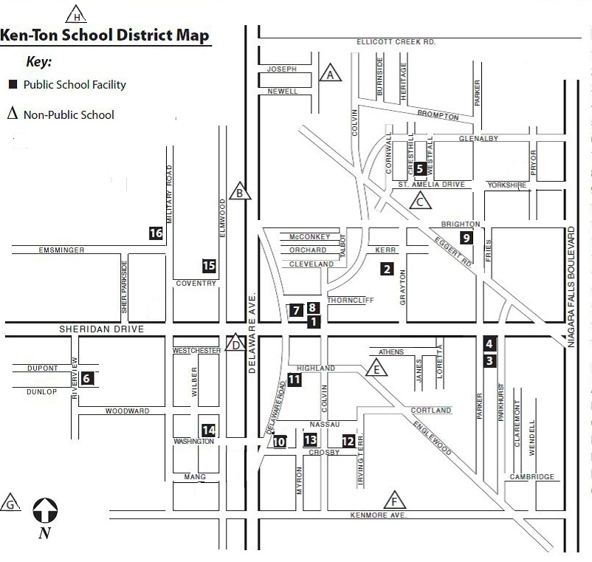

Public School Facilities |  |  | Non-Public Schools
1 | Administration Building |  | A | Cardinal O’Hara High School
2 | Edison Elementary |  | B | Mount St. Mary Academy
3 | Franklin Elementary |  | C | St. Amelia School
4 | Franklin Middle School |  | D | St. Andrew’s Country Day School
5 | Hamilton Elementary |  | E | St. John the Baptist
6 | Holmes Elementary |  | F | St. Joseph Collegiate Institute
7 | Hoover Elementary |  | G | Charter School for Applied Technology
8 | Hoover Middle School
9 | Kenmore East High School
10 | Kenmore Middle School
11 | Kenmore West High School
12 | Lindbergh Elementary
13 | Longfellow Building
14 | Roosevelt Elementary
15 | Sheridan Building
16 | Transportation Building

