Name Mathematics- Investigation 10
Date Brunner

The Scarecrow’s Theorem—True or False?

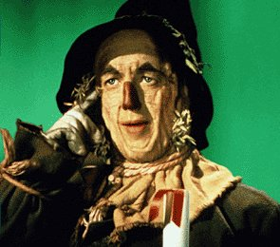
“The sum of the square roots of any two sides of an isosceles triangle is equal to the square root of the remaining side. Oh, joy, oh, rapture. I’ve got a brain!” –The Scarecrow, The Wizard of Oz, 1939.

An isosceles triangle is a polygon having three sides, two of which are congruent, that is to say they have the same measure—in this case they are the same length. Isosceles triangles also have the added characteristic of having two congruent angles (again, the same degree measure) opposite the pair of congruent sides. The third side of an isosceles triangle, or base, is of any length as long as it does not exceed the length of the sum of the two congruent sides, otherwise the triangle would not be able to form a closed polygon (and therefore would not be a polygon at all).

In this investigation you will analyze several different isosceles triangles to see if the Scarecrow’s Theorem is correct. Since we will not actually prove it to be true or false we will only determine what we think is the truth about the Scarecrow’s Theorem. After investigating enough isosceles triangles we will make a determination, but we must keep in mind that our conclusion is makes use of what in mathematics is called inferential reasoning. This means we think something is true, or false, based on investigation and experimentation—we didn’t actually prove it.

On the next page you will complete a T-Chart for several isosceles triangles. You will necessarily determine the square roots of some numbers, add them and compare them. You will then answer some investigation questions. Lastly, based on your findings you will decide whether or not you think the Scarecrow’s Theorem is correct or not.

OVER
210
210
64
64
100

100

455
75
10

1 2 3
Triangle | Side A | Sq Root A | Side B | Sq Root B | Sum of Sq Rt A + Sq Rt B | Side C | Sq Root C
1
2
3
For each triangle shown choose sides A, B, and C for the table below.

1) Did the sum of the square roots of sides A and B equal the square root of side C for each of the three isosceles triangles? If not, explain your findings.

For isosceles triangle 4, perform the same calculations and determine whether or not it obeys the Scarecrow’s Theorem.
Work Space

35 35

140
4

2) Did isosceles triangle 4 obey (agree with) Scarecrow’s Theorem?

3) Your Conclusion—Is the Scarecrow correct? Explain.

