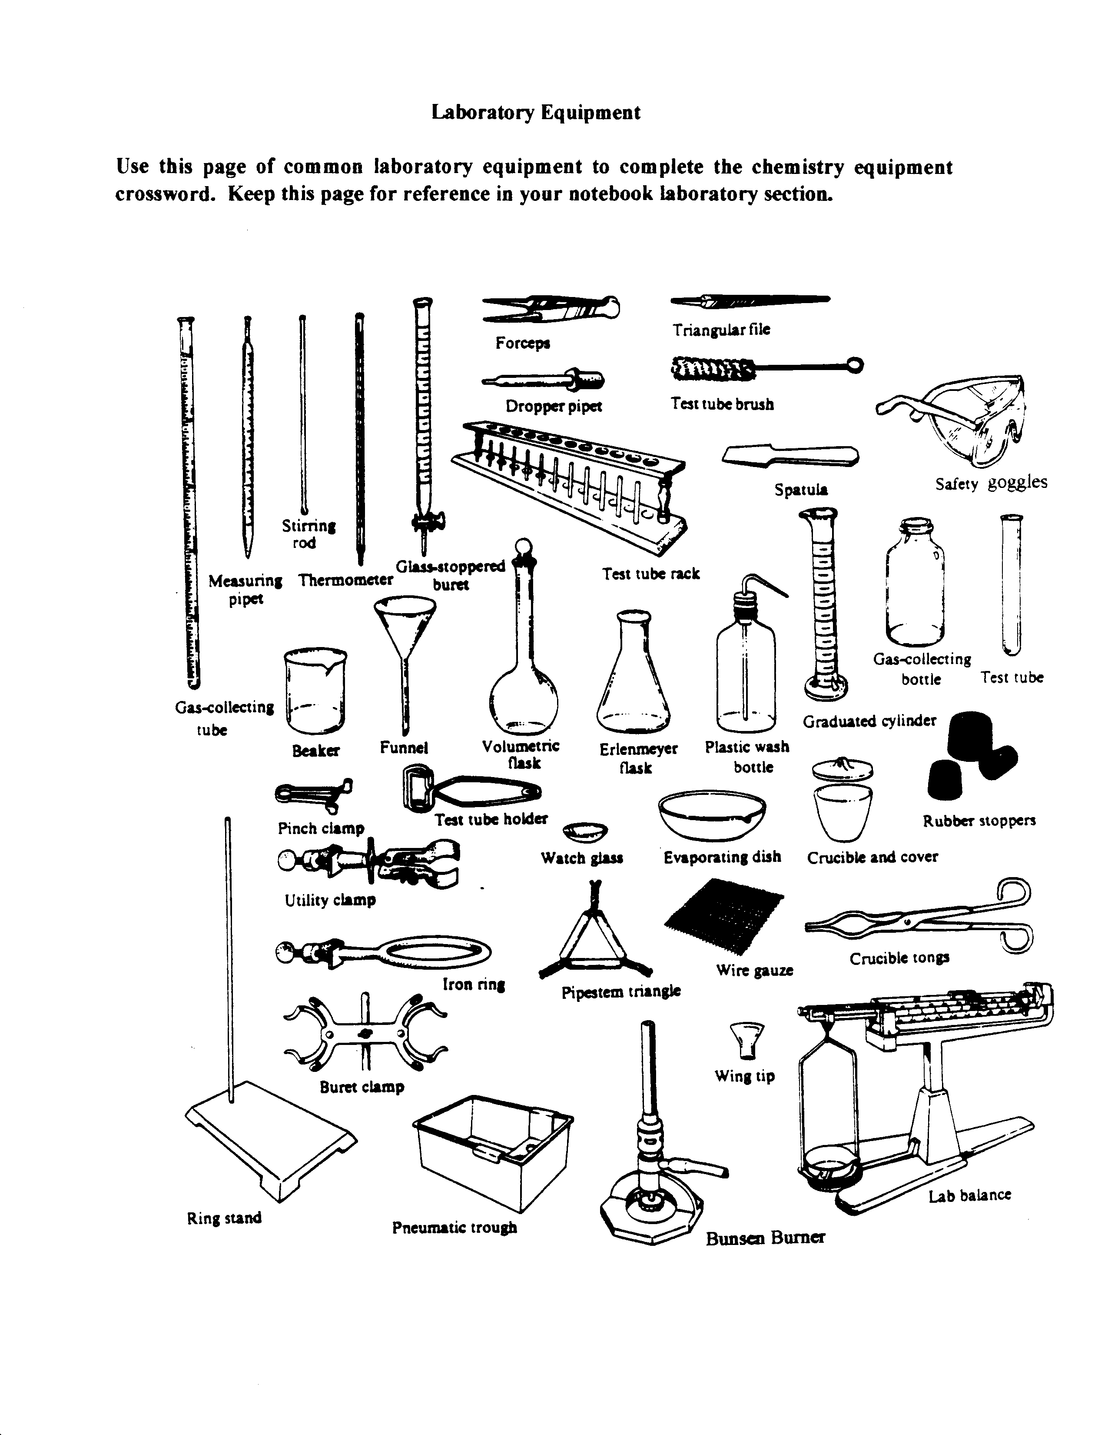

Name: |  | Lab Day & Per.:
Lab Partner: | Lab Partner:
Date Due:` | Lab Partner:

Lab 1: The Safety Lab

This sheet will be turned in along with the answers to the questions below written in complete sentences on looseleaf. Also complete the crossword puzzle on the back of this page.

Safety Lab Completed? Teacher Check:

Questions:

- What is the appropriate way to dress for lab?

- Your lab partner is not wearing goggles! Oh no! Your partner splashed some chemical and it got into their eyes! What can you do to help? (Laughing is not going to help)

- A test tube breaks on the lab table. What steps should you take to clean up and dispose this broken glass?

- In cleaning up after lab, where should you dispose of used or excess chemicals?

- What do you think is the most important safety rule to follow in the laboratory? Explain why you chose the rule that you did.

- What requirements must be met in lab in order for you to take the Physical Setting: Chemistry Regents exam?

- What is our late lab policy?

- What is our incomplete lab policy?

- If you are absent for lab,

- When should you make up the missed lab?
- When should you turn in the lab that was due the day your were absent?

10) What is the policy on food, drink and horseplay in lab?

