**Name: _________________________________**

**WR8**

**1.** The cumulative frequency graph shows the amount of time in minutes, 200 students spend waiting for their train on a particular morning.

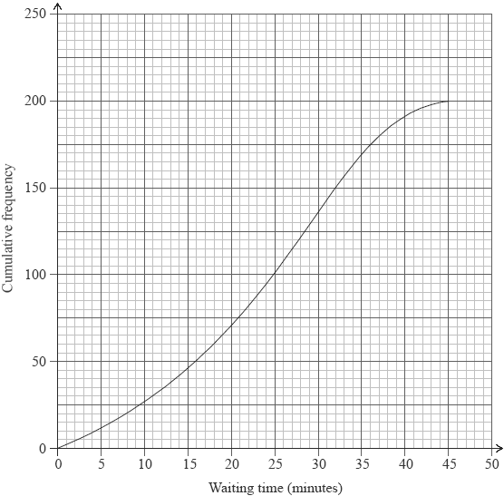

(a) Write down the median waiting time.

(1)

(b) Find the interquartile range for the waiting time.

(2)

The minimum waiting time is zero and the maximum waiting time is 45 minutes.

(c) Draw a box and whisker plot on the grid below to represent this information.

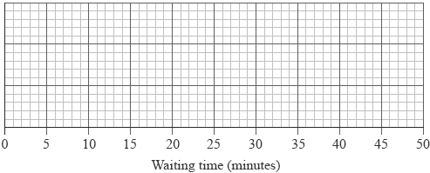

(3)

(Total 6 marks)

**2.** The mean of the ten numbers listed below is 6.8.

8, 5, 5, 10, 8, 4, 9, 7, *p*, *q*

(a) Write down an equation in terms of *p* and *q*.

(2)

The mode of these ten numbers is five and *p* is less than *q*.

(b) Write down the value of

(i) *p*;

(ii) *q*.

(2)

(c) Find the median of the ten numbers.

(2)

(Total 6 marks)

**3.** The diagram represents a small, triangular field, ABC, with BC = 25 m, angle BAC = 55° and angle ACB = 75°.

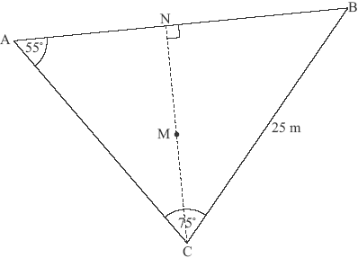

***diagram not to scale***

(a) Write down the size of angle ABC.

(1)

(b) Calculate the length of AC.

(3)

(c) Calculate the area of the field ABC.

(3)

N is the point on AB such that CN is perpendicular to AB. M is the midpoint of CN.

(d) Calculate the length of NM.

(3)

A goat is attached to one end of a rope of length 7 m. The other end of the rope is attached to the point M.

(e) Decide whether the goat can reach point P, the midpoint of CB. Justify your answer.

(5)

(Total 15 marks)

**4.** The diagram shows a triangle ABC in which AC = 17 cm. M is the midpoint of AC.  
Triangle ABM is equilateral.

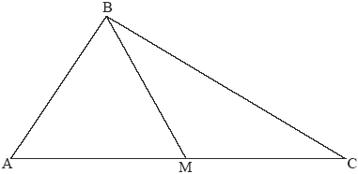

***diagram not to scale***

(a) Write down

(i) the length of BM in cm;

(ii) the size of angle BMC;

(iii) the size of angle MCB.

(3)

(b) Calculate the length of BC in cm.

(3)

(Total 6 marks)

**5.** The figure shows the graphs of the functions *f*(*x*)= *x*2 – 2 and *g*(*x*)= *x*.

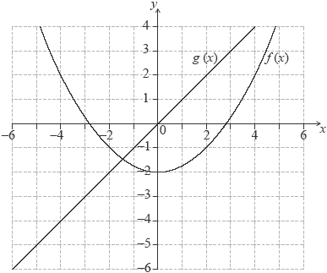

(a) Differentiate *f*(*x*)with respect to *x.*

(1)

(b) Differentiate *g*(*x*)with respect to *x.*

(1)

(c) Calculate the value of *x* for which the gradients of the two graphs are the same.

(2)

(d) Draw the tangent to the parabola at the point with the value of *x* found in part (c).

(2)

(Total 6 marks)

**6.** Consider the function *f*(*x*) = *x*3 + , *x* ≠ 0.

(a) Calculate *f*(2).

(2)

(b) Sketch the graph of the function *y* = *f*(*x*) for –5≤ *x* ≤ 5 and –200 ≤ *y* ≤ 200.

(4)

(c) Find *f*′(*x*).

(3)

(d) Find *f*′(2).

(2)

(e) Write down the coordinates of the local maximum point on the graph of *f.*

(2)

(f) Find the range of *f.*

(3)

(g) Find the gradient of the tangent to the graph of *f* at *x* = 1.

(2)

There is a second point on the graph of *f* at which the tangent is parallel to the tangent at *x* = 1.

(h) Find the *x*-coordinate of this point.

(2)

(Total 20 marks)

**7.** A concert choir is arranged, per row, according to an arithmetic sequence. There are 20 singers in the fourth row and 32 singers in the eighth row.

(a) Find the common difference of this arithmetic sequence.

(3)

There are 10 rows in the choir and 11 singers in the first row.

(b) Find the **total** number of singers in the choir.

(3)

(Total 6 marks)

**8.** Astrid invests 1200 euros for five years at a nominal annual interest rate of 7.2 %, **compounded monthly**.

(a) Find the interest Astrid has earned during the five years of her investment.  
**Give your answer correct to two decimal places**.

(3)

Helen invests 1200 euros in an annual **simple interest** scheme for five years.  
She earns **the same** interest as Astrid.

(b) Find the simple interest rate of this scheme.

(3)

(Total 6 marks)