**Name _______________________________________**

**WR 7**

**1.** Susi travels from Singapore to Thailand and changes 1500 Singapore dollars (SGD) to Thai baht (THB). The exchange rate is 1 SGD buys 21.03464 THB.

(a) Calculate the number of Thai baht Susi buys. Give your answer **correct to the nearest baht**.

(2)

Susi leaves Thailand and travels to Indonesia. She has 20 000 THB and uses these to buy Indonesian rupiah (IDR). The exchange rate is 3.28352 THB buys 1000 IDR.

(b) Calculate the **total** number of Indonesian rupiah Susi receives, **correct to the nearest thousand rupiah**.

(2)

Susi wants to find the approximate exchange rate between Singapore dollars and Indonesian rupiah and uses the exchange rates for Thai baht to do this.

(c) Calculate Susi’s exchange rate between Singapore dollars and Indonesian rupiah.  
Give your answer in the form 1 SGD buys *x* IDR, where *x* is given correct to the nearest rupiah.

(2)

(Total 6 marks)

**2.** José stands 1.38 kilometres from a vertical cliff.

(a) Express this distance in metres.

(1)

José estimates the angle between the horizontal and the top of the cliff as 28.3° and uses it to find the height of the cliff.

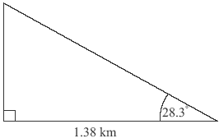

***diagram not to scale***

(b) Find the height of the cliff according to José’s calculation. **Express your answer in metres, to the nearest whole metre.**

(3)

(c) The actual height of the cliff is 718 metres. Calculate the percentage error made by José when calculating the height of the cliff.

(2)

(Total 6 marks)

**3.** Consider two propositions *p* and *q*.

(a) Complete the truth table below.

|  |  |  |  |  |  |
| --- | --- | --- | --- | --- | --- |
| *p* | *q* | ¬*q* | *p*  ¬*q* | ¬*p* | ¬*p*  *q* |
| T | T |  |  |  |  |
| T | F |  |  |  |  |
| F | T |  |  |  |  |
| F | F |  |  |  |  |

(4)

(b) Decide whether the compound proposition

(*p*  ¬*q*)  (¬*p*  *q*)

is a tautology. State the reason for your decision.

(2)

(Total 6 marks)

**4.** A fitness club has 60 members. 35 of the members attend the club’s aerobics course (*A*) and 28 members attend the club’s yoga course (*Y*). 17 members attend both courses.  
A Venn diagram is used to illustrate this situation.

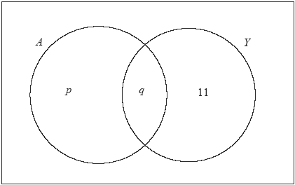

(a) Write down the value of *q*.

(1)

(b) Find the value of *p*.

(2)

(c) Calculate the number of members of the fitness club who attend neither the aerobics course (*A*) nor the yoga course (*Y*).

(2)

(d) Shade, on your Venn diagram, *A*′  *Y*.

(1)

(Total 6 marks)

**5.** The graph of *y* = 2*x*2– *rx* + *q* is shown for –5 ≤ *x* ≤ 7.

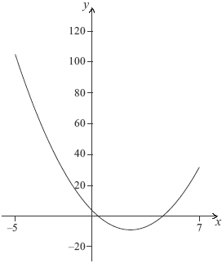

The graph cuts the *y-*axis at (0, 4).

(a) Write down the value of *q.*

(1)

The axis of symmetry is *x* = 2.5.

(b) Find the value of *r.*

(2)

(c) Write down the minimum value of *y.*

(1)

(d) Write down the range of *y.*

(2)

(Total 6 marks)

**6.** Tony wants to carry out a *χ*2 test to determine whether or not a person’s choice of one of the three professions – engineering, medicine or law – is influenced by the person’s sex (gender).

(a) State the null hypothesis, H0, for this test.

(1)

(b) Write down the number of degrees of freedom.

(1)

Of the 400 people Tony interviewed, 220 were male and 180 were female.  
80 of the people had chosen engineering as a profession.

(c) Calculate the expected number of female engineers.

(2)

Tony used a 5 % level of significance for his test and obtained a *p*-value of 0.0634 correct to 3 significant figures.

(d) State Tony’s conclusion to the test. Give a reason for this conclusion.

(2)

(Total 6 marks)

**7.** 120 Mathematics students in a school sat an examination. Their scores (given as a percentage) were summarized on a cumulative frequency diagram. This diagram is given below.

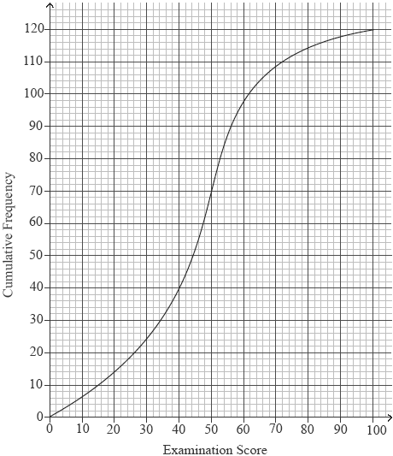

(a) Complete the grouped frequency table for the students.

|  |  |  |  |  |  |
| --- | --- | --- | --- | --- | --- |
| Examination Score *x* (%) | 0 ≤ *x* ≤20 | 20 < *x* ≤ 40 | 40 < *x* ≤ 60 | 60 < *x* ≤ 80 | 80 < *x* ≤ 100 |
| Frequency | 14 | 26 |  |  |  |

(3)

(b) Write down the mid-interval value of the 40 < *x* ≤ 60interval.

(1)

(c) Calculate an estimate of the mean examination score of the students.

(2)

(Total 6 marks)

**8.** The diagram shows a sketch of the function *f*(*x*) = 4*x*3 – 9*x*2 – 12*x* + 3.

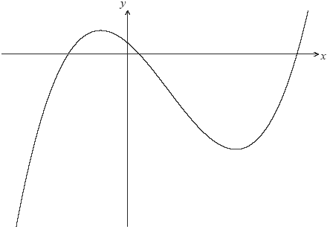

***diagram not to scale***

(a) Write down the values of *x* where the graph of *f*(*x*) intersects the *x-*axis.

(3)

(b) Write down *f′(x*).

(3)

(c) Find the value of the local maximum of *y* = *f*(*x*).

(4)

Let P be the point where the graph of *f*(*x*) intersects the *y-*axis.

(d) Write down the coordinates of P.

(1)

(e) Find the gradient of the curve at P.

(2)

The line, *L*, is the tangent to the graph of *f*(*x*) at P.

(f) Find the equation of *L* in the form *y* = *mx* + *c*.

(2)

There is a second point, Q, on the curve at which the tangent to *f*(*x*) is parallel to *L*.

(g) Write down the gradient of the tangent at Q.

(1)

(h) Calculate the *x*-coordinate of Q.

(3)

(Total 19 marks)

**9.** The stem and leaf diagram below shows the lengths of 22 metal components in cm.

|  |  |
| --- | --- |
| Stem | Leaf |
| 1 | 2, 2, 3, 7 |
| 2 | 4, 4, 4, 8, 9, 9 |
| 3 | 6, 7, 7 |
| 4 | 1, 1, 1, 1, 3, 5, 6 |
| 5 | 0, 1 |

Key: 1 | 2 means 1.2 cm

(a) Write down the modal length of the metal components.

(1)

(b) Find the median length of the metal components.

(2)

(c) Calculate the interquartile range of the lengths of the metal components.

(3)

(Total 6 marks)