**Weekly Review #2 Name: _______________________**

**SHOW ALL WORK**

**1.** The table below shows the frequency distribution of the number of dental fillings for a group of 25 children.

|  |  |  |  |  |  |  |
| --- | --- | --- | --- | --- | --- | --- |
| Number of fillings | 0 | 1 | 2 | 3 | 4 | 5 |
| Frequency | 4 | 3 | 8 | *q* | 4 | 1 |

(a) Find the value of *q.*

(2)

(b) Use your graphic display calculator to find

(i) the mean number of fillings;

(ii) the median number of fillings;

(iii) the standard deviation of the number of fillings.

(4)

(Total 6 marks)

**2.** Police in a town are investigating the theft of mobile phones one evening from three cafés, “Alan’s Diner”, “Sarah’s Snackbar” and “Pete’s Eats”.

They interviewed two suspects, Matthew and Anna about that evening.

Matthew said:

“I visited Pete’s Eats and visited Alan’s Diner and I did not visit Sarah’s Snackbar”

Let *p,* *q* and *r* be the statements:

*p* : I visited Alan’s Diner  
*q* : I visited Sarah’s Snackbar  
*r* : I visited Pete’s Eats

(a) Write down Matthew’s statement in symbolic logic form.

(3)

What Anna said was lost by the police, but in symbolic form it was

(*q*  ¬*p*

(b) Write down, in words, what Anna said.

(3)

(Total 6 marks)

**3.** A satellite travels around the Earth in a circular orbit 500 kilometres above the Earth’s surface.  
The radius of the Earth is taken as 6400 kilometres.

(a) Write down the radius of the satellite’s orbit.

(1)

(b) Calculate the distance travelled by the satellite in one orbit of the Earth.  
Give your answer correct to the nearest km.

(3)

(c) Write down your answer to (b) in the form *a* × 10*k*, where 1≤ *a* < 10, *k*  .

(2)

(Total 6 marks)

**4.** The graph of the quadratic function *f*(*x*) = 3+ 4*x* – *x*2 intersects the *y-*axis at point A and has its vertex at point B.

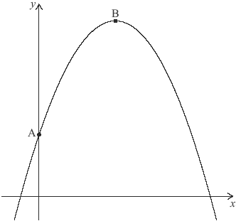

(a) Find the coordinates of B.

(3)

Another point, C, which lies on the graph of *y* = *f*(*x*) has the same *y-*coordinate as A.

(b) (i) Plot and label C on the graph above.

(ii) Find the *x-*coordinate of C.

(3)

(Total 6 marks)

**5.** A room is in the shape of a cuboid. Its floor measures 7.2 m by 9.6 m and its height is 3.5 m.

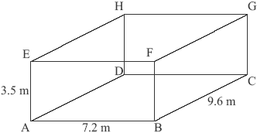

***diagram not to scale***

(a) Calculate the length of AC.

(2)

(b) Calculate the length of AG.

(2)

(c) Calculate the angle that AG makes with the floor.

(2)

(Total 6 marks)

**6.** The probability that it rains today is 0.4. If it rains today, the probability that it will rain tomorrow is 0.8. If it does not rain today, the probability that it will rain tomorrow is 0.7.

(a) Complete the tree diagram below.

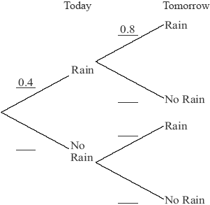

(3)

(b) Calculate the probability of rain tomorrow.

(3)

(Total 6 marks)