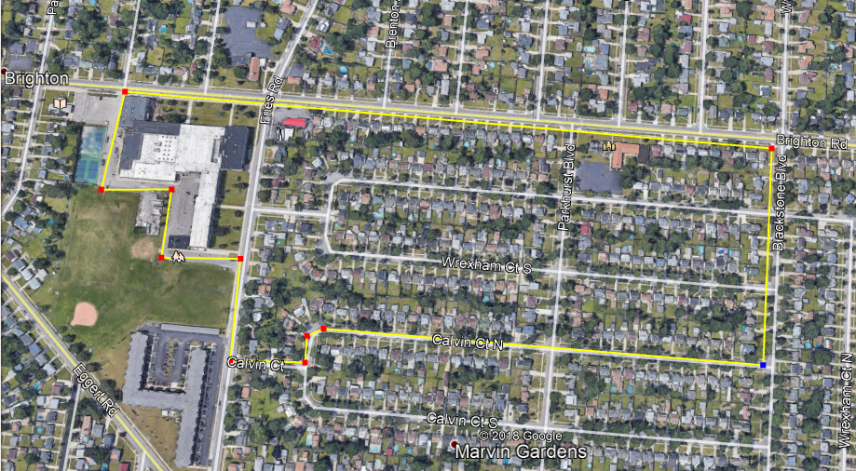

BLACKSTONE:

Right on Brighton
Right on Blackstone
Right on Calvin Ct. N
Left on Calvin Ct.
Right on Fries
Left into KE parking lot off of Fries

Distance: 1.4 miles

